Hw 4 Bandwidth Problem

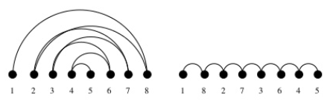

By Siyuan Zou, 111639762

# Analysis of Pruning

In this Homework, after finishing up with the basic scheme of generating permutation via. Backtracking, I started off with a simple pruning of having an upper bound. This reduce the problem by able to cut through permutation that is not useful to the solving of the bandwidth problem. Next, I decide to take care of the lower bound. Lastly, I decide to eliminate half of the permutation by not caring about the reverse of another permutation. However, I was unsuccessful at reach the result.